**Relative Risk Weighting (RRW)**

Since cost estimators are not expert in every conceivable space system, they must work with engineering experts. The cost estimator's job, when working with the engineering experts, is to elicit risk information in a form he or she can translate into cost impacts. Discussions can take the form of interviews about the risks in a given WBS element and how relatively risky that WBS element's worst case (pessimistic), best case (optimistic) and most likely case (reference) scenarios are.

A technique known as Relative Risk Weighting (RRW) adds a dimension for describing a worst case, best case, and reference case with respect to "technical" risk. This three-dimensional matrix produces relative scores for each case and cost-risk adjustment factors for constructing triangular WBS cost-risk distributions. The RRW process is a suggested method to first get the engineers to characterize the WBS element in terms of the KEPPs that will be affected by programmatic/ technology cost-risk drivers and second, develop pessimistic, optimistic, and reference scenarios in terms of a WBS element's KEPPs and rate these scenarios with respect to appropriate programmatic/technology cost-risk drivers (e.g., technology level (TRL), design/engineering, schedule, integration, etc.). If possible, it is preferred to have more than one engineer in the assessment due to the discussions that naturally evolve. These multi-party discussions usually produce a synthesis assessment that is of a higher quality due to the different perspectives each engineer brings.

This approach is not the only valid way to do cost-risk assessment; however, it is presented here because it addresses all of the major elements involved in cost-risk assessment. Foremost among these major elements is the ability to create credible and defensible inputs to Monte Carlo simulation calculators like @RISK and Crystal Ball avoiding the "garbage in, garbage out" syndrome. It is also presented here for the cost estimator who finds himself in the position of defending all aspects of a cost-risk assessment.

Pre-established and well-defined risk driver categories function as criteria against which pessimistic, optimistic, and reference WBS element scenarios can be evaluated. Some examples of such criteria and intensity rating scales for technology state of the art, design/engineering, complexity and interaction/dependencies are presented in [Figure 2-17](http://ceh.nasa.gov/ceh_2008/volume_2/2_5_relative_risk_weighting_rrw.htm#Figure_2-17_Risk) through [Figure 2-20](http://ceh.nasa.gov/ceh_2008/volume_2/2_5_relative_risk_weighting_rrw.htm#Figure_2-20_Interaction).

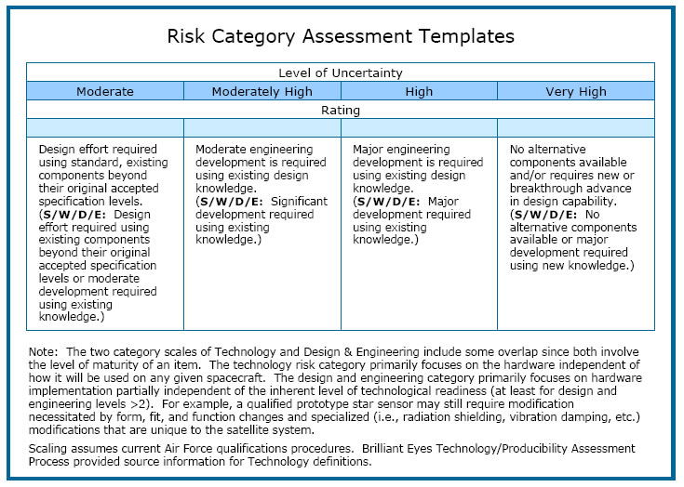

Figure 2-17. Risk Assessment Template Example

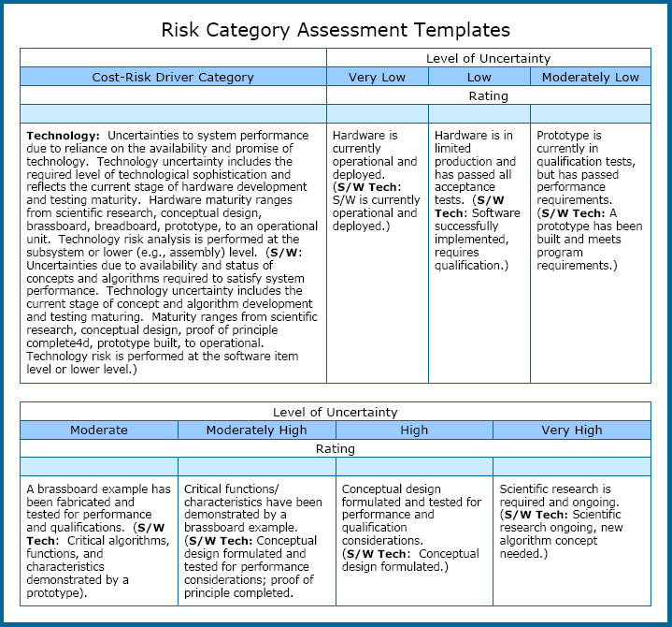

Figure 2-18. Design & Engineering Risk Template Example

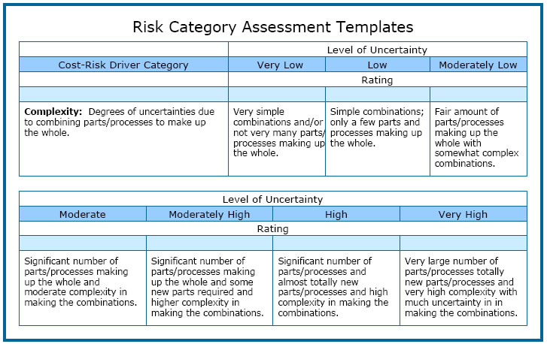

Figure 2-19. Complexity Risk Template Example

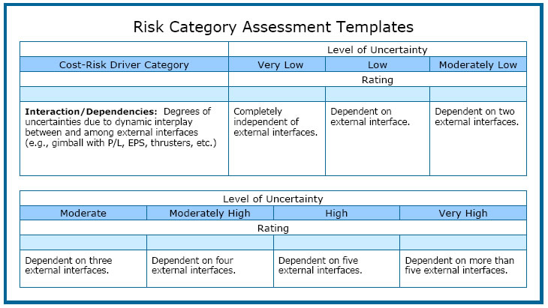

Figure 2-20. Interaction/Interdependency Template Example

It is important to note that not all WBS elements need to be rated against technology state of the art, design/engineering, complexity or interaction/dependencies rating scales. The general rule is that whatever cost-risk driver categories are relevant to the WBS element being rated are the ones that should be used. This may involve developing different risk driver categories such as integration, schedule, manufacturing, etc., with associated definitions for both the cost-risk driver and the intensity scales used to rate the degree of risk level involved for the pessimistic, optimistic, and reference scenarios. Cost-risk driver templates are the foundation for the interactions between the cost estimators and engineers in determining risk levels in each risk scenario for later use in quantifying their cost impacts.

The risk scores for each WBS element risk scenario are developed by first deriving weights for both the risk driver categories and the rating scale intensities (e.g., very high or medium low etc.). A useful technique for deriving the weights for both risk driver categories and rating scale intensities is the application of the Analytic Hierarchy Process (AHP),**[9]** Weights resulting from the AHP are ratio-scale weights, that is, they have a meaningful zero point and thus have the integrity for use in all mathematical operations. The same cannot be said of ordinal or even interval level numbers., The scores result from the sum of the products of each risk category weight and each rating scale intensity weight.

The RRW process involves creating pessimistic, optimistic, and reference risk profiles for a CER-driving parameter (e.g., weight). The application of the resulting RRW ratios to the nominal (reference) parameter value from the CADRe reflects the parameter's potential range of values (see [Figure 2-21](http://ceh.nasa.gov/ceh_2008/volume_2/2_5_relative_risk_weighting_rrw.htm#Figure_2-21_Reference)). When this range of values is entered into the CER, a range of costs is produced that adds to the cost range driven by the uncertainty inherent within the CER itself.



Figure 2-21. Reference Parameter Values